Tree Journeyman 325 Servo Motor Timing Belts:
Span Length = xxxxx mm
or
Span Length Formula:
S = $\sqrt{CD^{2}- {\left(D-d\right)}^{2}/4}$
Where: S=Calculated Span Length (mm)
CD=Center Distance (mm)
D=Large Pulley Dia. (mm)
d=Small Pulley Dia. (mm)

X-Axis:
Brand Belt: Bando Synchrolink
Number on Belt: 270L-0756 (SB-26)
PowerGrip Timing Belt – L (0.375”)
Mass Constant = 3.2 g/m
Belt Width = .750”
Frequency on Correctly Tensioned Belt: 52Hz
Speed Ratio =0.500
Pitch Diameter of the Large Pulley (26 tooth) = Ø3.104”
Pitch Diameter of the Small Pulley (13 tooth) = Ø1.552”
Center to Center axis span (used in formula above) = 9.8125”
Checked Belt Tension was at a Frequency of 50-51 Hz.

Y-Axis:
Brand Belt: Bando Synchrolink
Number on Belt: 322L-0756 (0949)
Mass Constant = 3.2 g/m
Belt Width = .750”
Frequency on Correctly Tensioned Belt: 52Hz
Speed Ratio =0.500
Pitch Diameter of the Large Pulley (30 tooth) = Ø3.581”
Pitch Diameter of the Small Pulley (15 tooth) = Ø1.790”
Center to Center axis span (used in formula above) = 11.8125”
Checked Belt Tension was at a Frequency of 52-53 Hz.

Z-Axis:
Brand Belt: Bando Synchrolink
Number on Belt: 225L-100G
Mass Constant = 3.2 g/m
Belt Width = 1.00”
Frequency on Correctly Tensioned Belt: 128Hz
Speed Ratio =0.400
Pitch Diameter of the Large Pulley (30 tooth) = Ø3.581”
Pitch Diameter of the Small Pulley (12 tooth) = Ø1.432”
Center to Center axis span (used in formula above) = 7.250”
Checked Belt Tension was at a Frequency of 128-129 Hz.

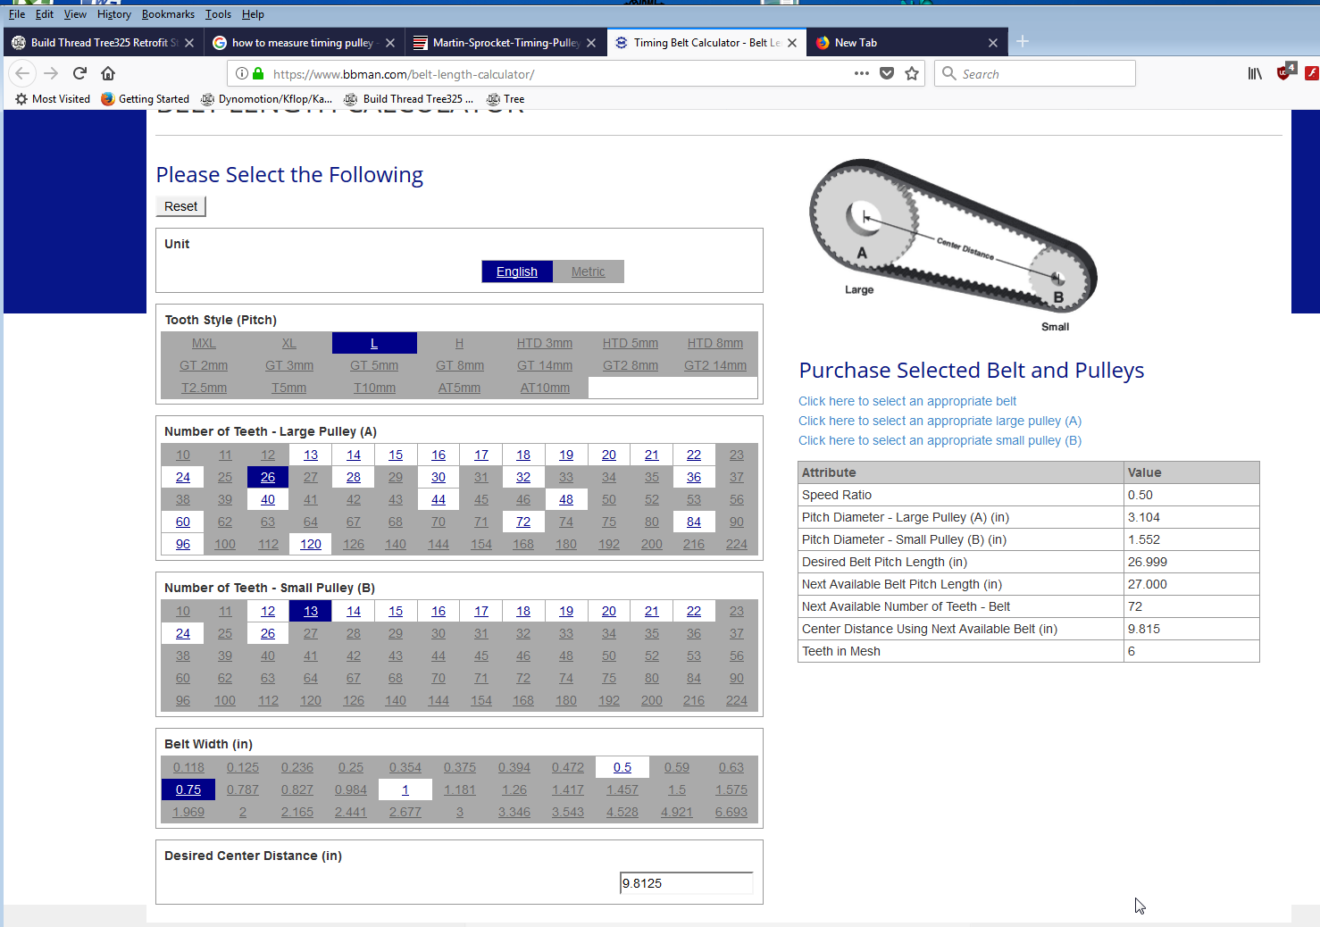
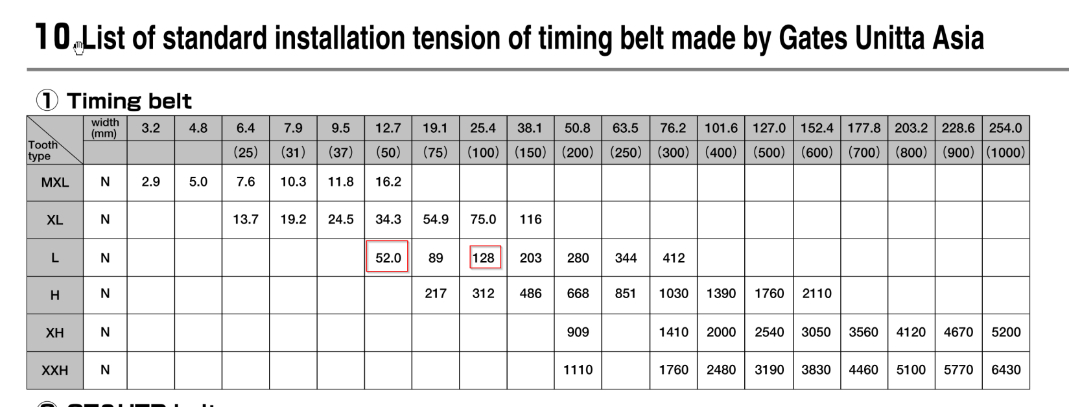
X-Axis calculations
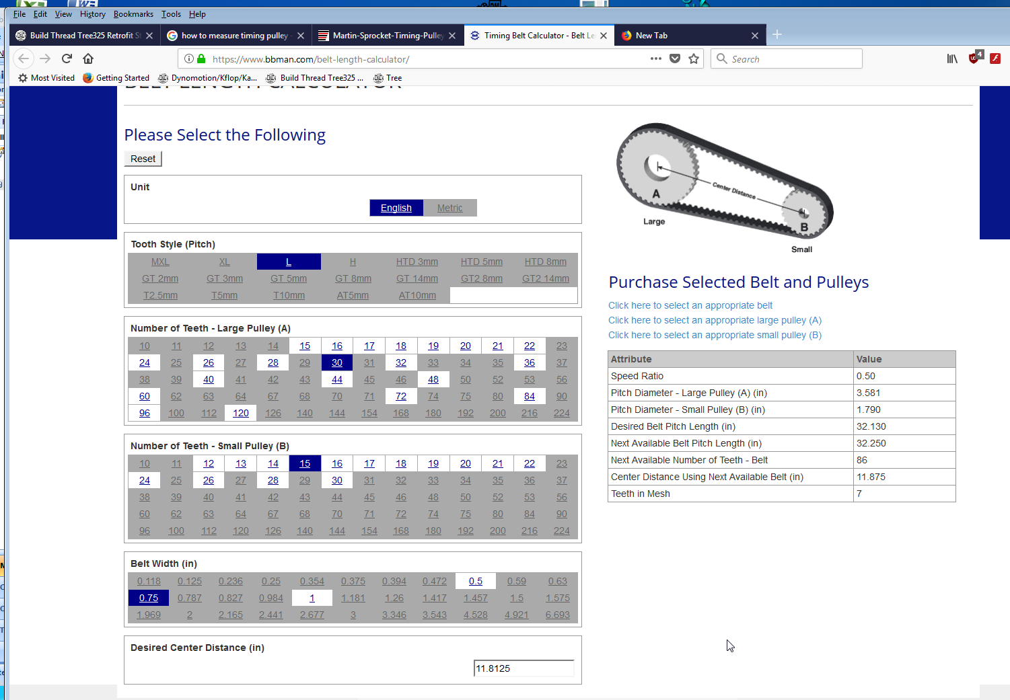
Y-Axis calculations
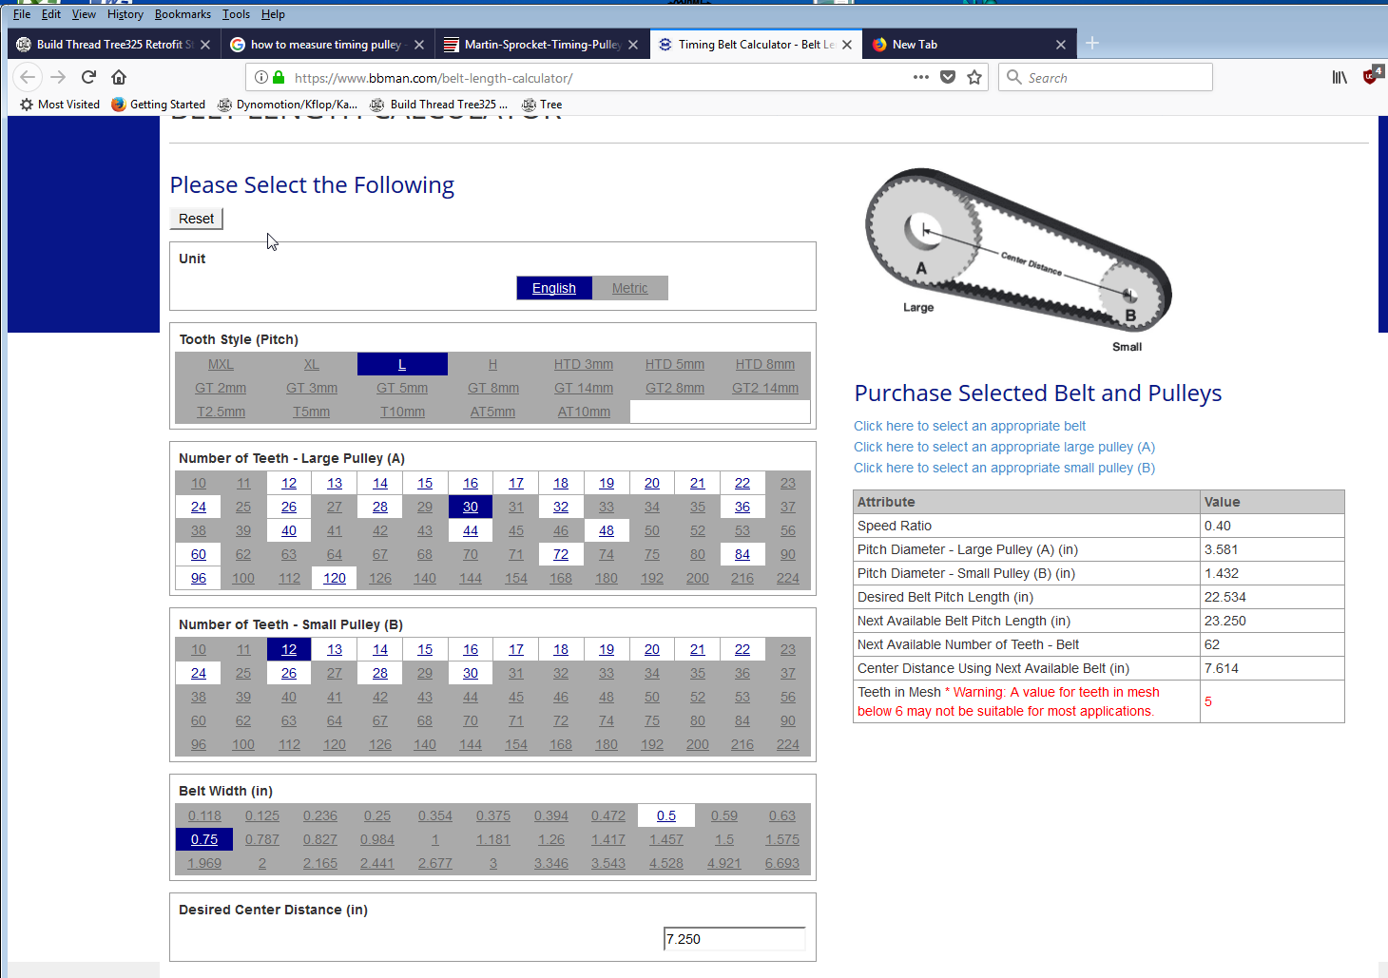
Z-Axis calculations

