KFLOP - Connector Pinouts
JP6 - Aux Connector #1 (On KFLOP)
Auxiliary connector which supplies power, reset, and 10 digital I/O (LVTTL 3.3V only) which is normally connected to optional expansion daughter boards (ie. SnapAmp 1000). If no expansion module is required, these digital I/O may be used for general purpose use. The first 8 IO (IO26-IO33) contain 150ohm termination resistors (pull downs).
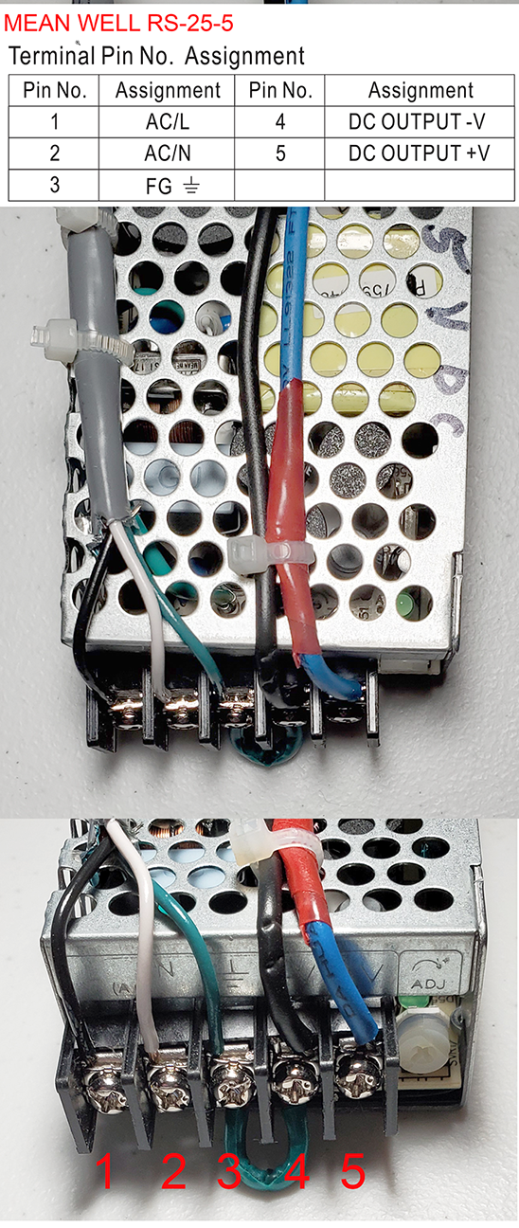
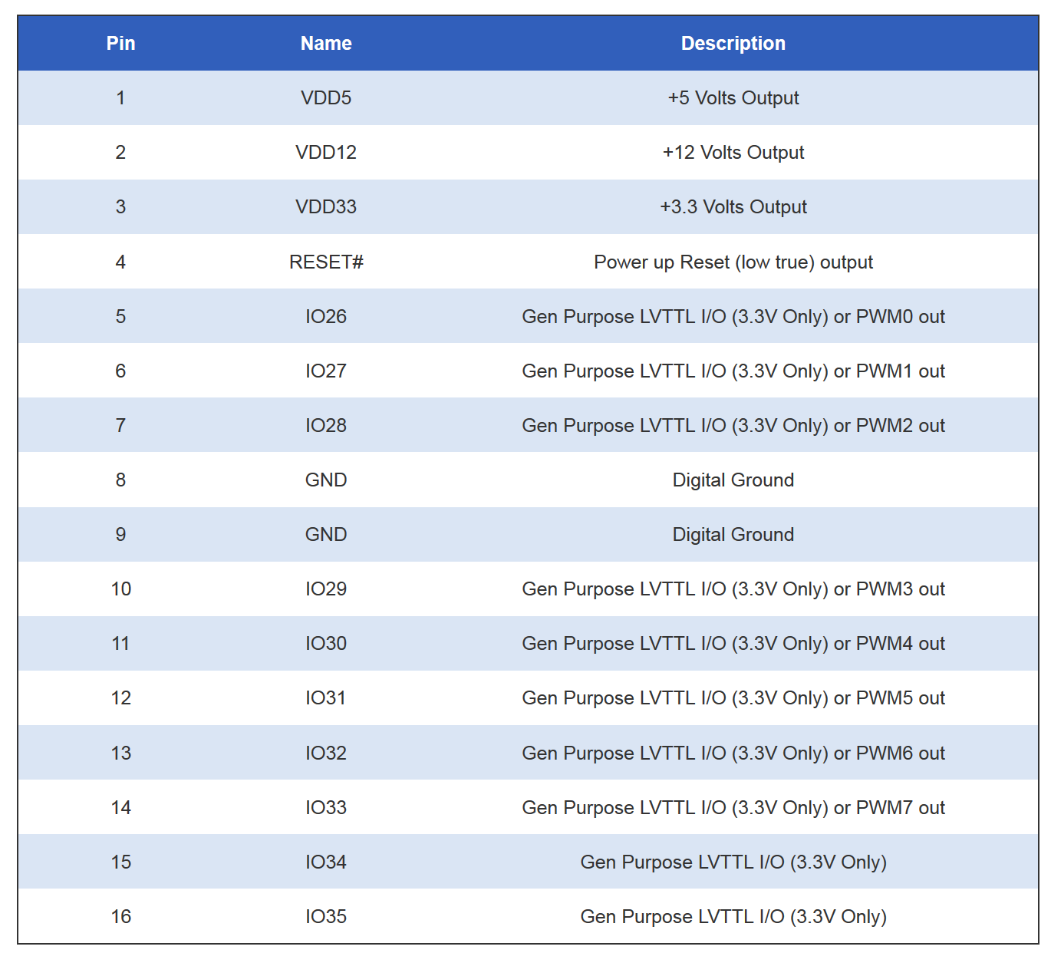
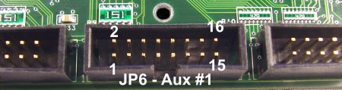

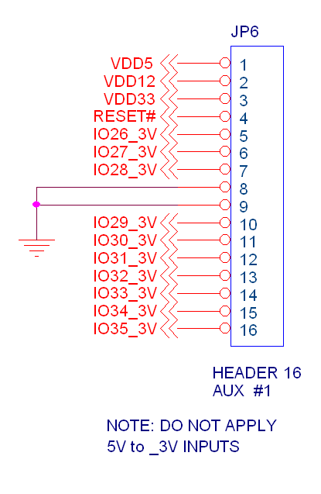

5VDC Power Supply

I get 1.5mV on Pin 16 from KFLOP with Pin 16 off and 3.27VDC when Pin 16 is turn on, which brings this relay in.

110 VAC NEG
POS

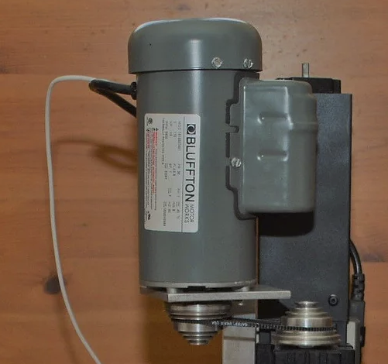
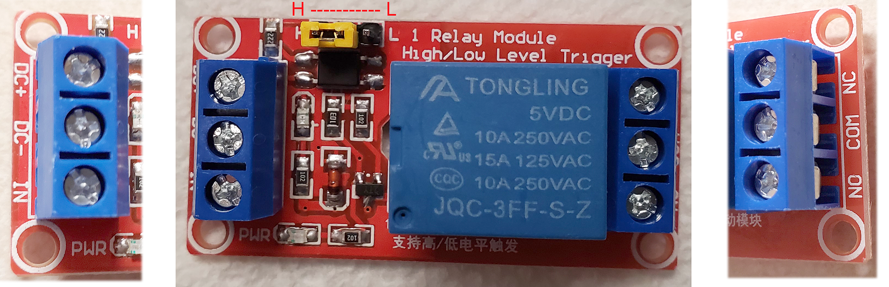

Youngneer 5v Relay Board Specs:

• 【1 Channel Relay Module】- This Relay Board provides a single relay that can be controlled by any 5V digital output from your microcontroller.
• 【Main Specification】- Peak Load of NO Connector: AC125~250V/10A, DC28~30V/10A; Trigger Current: 5mA; 4pcs * 3.1 mm Fixed Bolt Hole
• 【Adopted SMD Optocoupler Isolation】- The isolation circuit prevent damages to I / O port by relay switch current.

• 【Wide Application】- These 5v relay board works well with Arduino/ ARM /PIC /AVR /MCU/Raspberry/CNC machine/ PS4 etc.

• 【Humanization Design On Interfaces】- All interfaces can be directly wired out through the terminals.

Product description
Color: 5v Relay 1 Channel
Specification:
Material: Circuit board
Control signal: TTL
Rated load: AC125~250V/10A, DC28~30V/10A
Max. switch voltage: 250VAC, 30V
Trigger Voltage: 0-1.5V (LOW); 3-5V (High)
Trigger Current: 5mA
Max. Current: 190mA
Size: 50mm * 26mm * 18.5mm (1.9 inch *1.02 inch * 0.72 inch )
Input Connection:
DC +: Positive power supply (VCC)
DC-: Connect power negative ( GND)
IN: Control the pick up of replay by low level or high level
Output Connection:
Left Connection: “NO” means “Normally Open”
Middle Connection: “COM” means “Common”
Right Connection: “NC” means “Normally Closed”
High and Low Level Trigger Effective
High level trigger when the jumper cable connecting “High” to Short Circuit;
Low level trigger when the jumper cable connecting “Low” to Short Circuit;
LED Indicator Light:
Power Indicator: Green
Indicator of Relay Status: Red

