JP6 - Aux Connector #1 (On KFLOP)
Auxiliary connector which supplies power, reset, and 10 digital I/O (LVTTL 3.3V only) which is normally connected to optional expansion daughter boards (ie. SnapAmp 1000). If no expansion module is required, these digital I/O may be used for general purpose use. The first 8 IO (IO26-IO33) contain 150ohm termination resistors (pull downs).
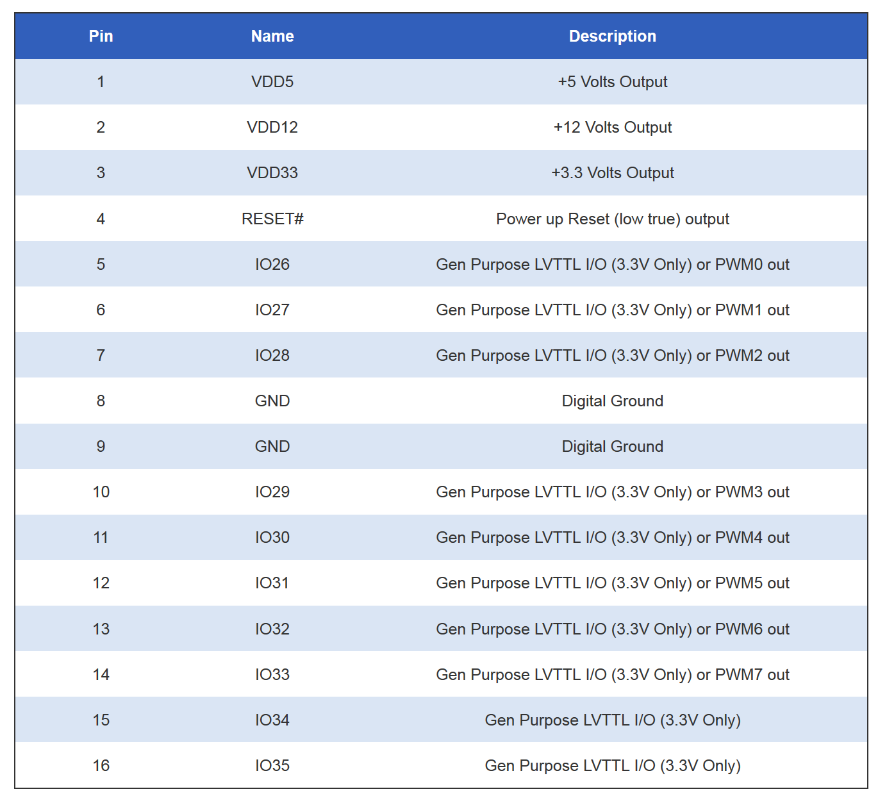
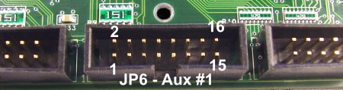

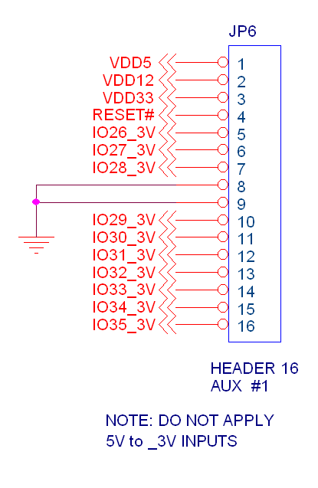

110 VAC NEG
POS

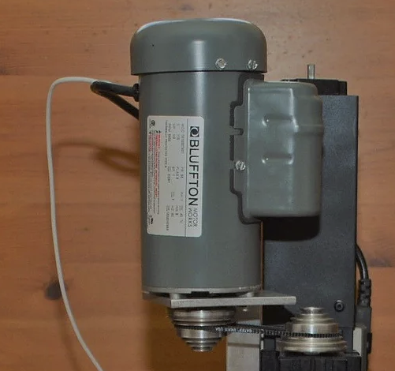
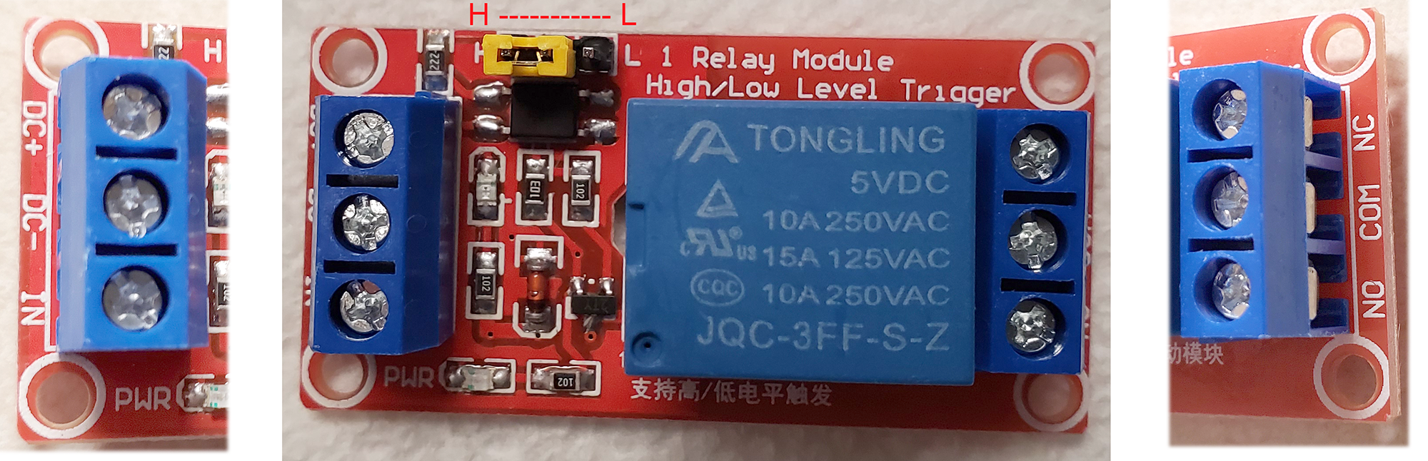

Youngneer 5v Relay Board Specs:

• 【1 Channel Relay Module】- This Relay Board provides a single relay that can be controlled by any 5V digital output from your microcontroller.
• 【Main Specification】- Peak Load of NO Connector: AC125~250V/10A, DC28~30V/10A; Trigger Current: 5mA; 4pcs * 3.1 mm Fixed Bolt Hole
• 【Adopted SMD Optocoupler Isolation】- The isolation circuit prevent damages to I / O port by relay switch current.

• 【Wide Application】- These 5v relay board works well with Arduino/ ARM /PIC /AVR /MCU/Raspberry/CNC machine/ PS4 etc.

• 【Humanization Design On Interfaces】- All interfaces can be directly wired out through the terminals.

Product description
Color: 5v Relay 1 Channel
Specification:
Material: Circuit board
Control signal: TTL
Rated load: AC125~250V/10A, DC28~30V/10A
Max. switch voltage: 250VAC, 30V
Trigger Voltage: 0-1.5V (LOW); 3-5V (High)
Trigger Current: 5mA
Max. Current: 190mA
Size: 50mm * 26mm * 18.5mm (1.9 inch *1.02 inch * 0.72 inch )
Input Connection:
DC +: Positive power supply (VCC)
DC-: Connect power negative ( GND)
IN: Control the pick up of replay by low level or high level
Output Connection:
Left Connection: “NO” means “Normally Open”
Middle Connection: “COM” means “Common”
Right Connection: “NC” means “Normally Closed”
High and Low Level Trigger Effective
High level trigger when the jumper cable connecting “High” to Short Circuit;
Low level trigger when the jumper cable connecting “Low” to Short Circuit;
LED Indicator Light:
Power Indicator: Green
Indicator of Relay Status: Red

